Name: Sergio Gutierrez

bitbucket Repo: <https://bitbucket.org/SergioZGutierrez/temperatureconverter/src/master/>

Exercise 2

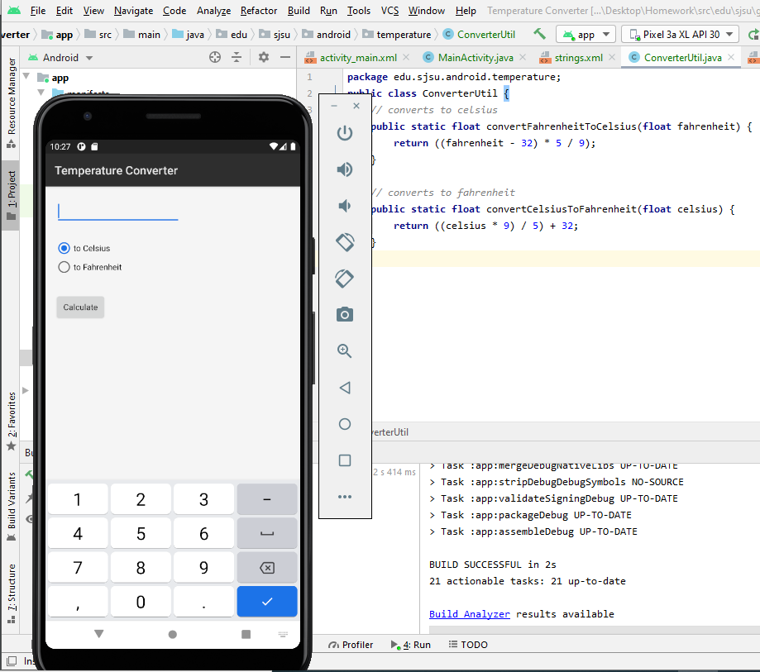

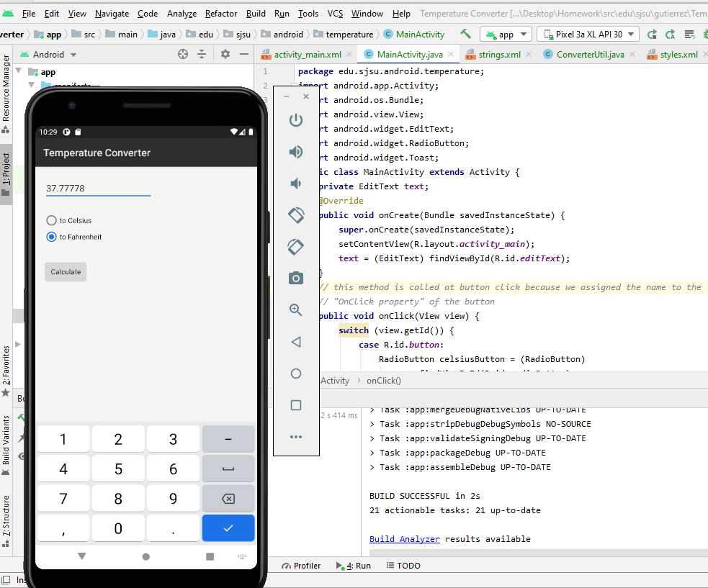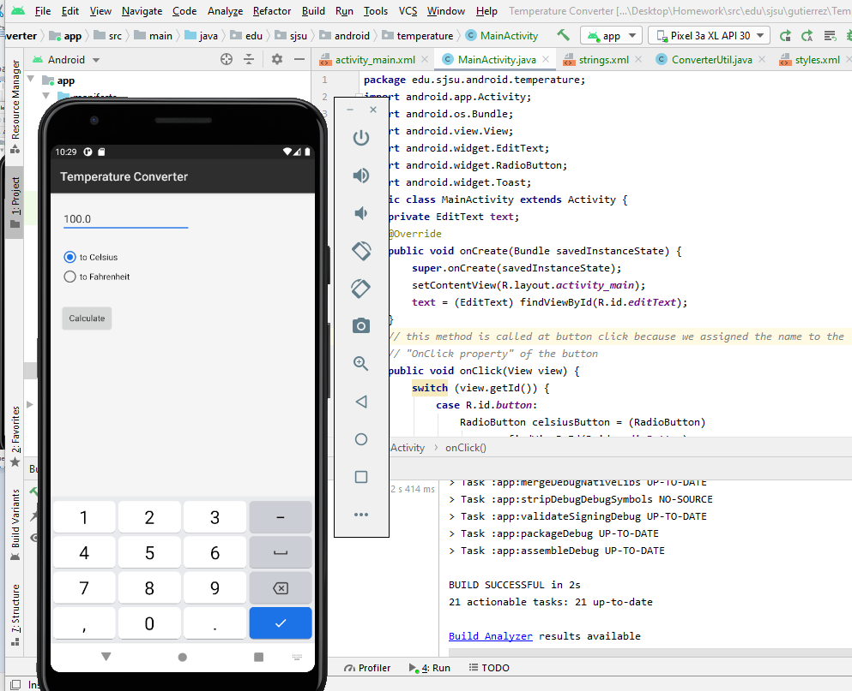

The exact pathway of where the .java files are located in my repository is:

<https://bitbucket.org/SergioZGutierrez/temperatureconverter/src/master/app/src/main/java/edu/sjsu/android/temperature/>